Protective Role of Zine Oxide Nanoparticles and Nigella Sativa Oil on Renal Toxicity Induced by Monosodium Glutamate in Adult Male Albino Rats.
Abstract
Background:
A flavour enhancer that is frequently utilized is monosodium glutamate (MSG). This may result in kidney injury due to oxidative stress. Nigella sativa oil (NSO) and zinc oxide nanoparticles
(ZnO-NPs) have the potential to exert renoprotective effects.
Aim: This study was performed to compare between protective effects ZnO-NPs or NSO alone and combined on renal toxicity induced by MSG. Methods: There were five groups of 60 healthy adult albino male rats. Group 1 was the control group, and Group 2 received MSG orally at a dosage of 200 mg/kg bw/day. Group 3 was administered MSG orally and ZnO-NPs intraperitoneally at a rate of 5 mg/kg bw/day. Group 4 was administered MSG with NSO orally at a rate of 2 ml/kg bw/day. Group 5 received MSG along with ZnO-NPs and NSO. All medications were administered for a period of four weeks. Kidney samples were processed for light and electron microscopic examinations at the end of the experiment. Results: MSG-treated rats had histological and ultrastructural kidney damage including shrunken glomeruli, widened Bowman’s space, tubular degeneration and vacuolated cytoplasm. The ZnO-NPs group showed moderate protection with nearly normal glomeruli and minimal tubular changes. The NSO group showed mild protection with partial preservation of glomerular and tubular structures. Combined treatment with ZnO-NPs and NSO resulted in the best results with kidneys appearing nearly normal and closely similar to control group.
Conclusion:
Combined use of ZnO-NPs and NSO improved kidney structure in MSG-induced toxicity rats.
Keywords: Monosodium glutamate, MSG, Renal toxicity, Zinc oxide nanoparticles, Nigella sativa oil.

Introduction:
One of the most commonly used flavour enhancers is MSG. According to reports, it has been linked to kidney injury by causing oxidative stress, disrupting renal structure, and increasing inflammation. ^{[1]} ^{[ 2]}
The renoprotective effects of ZnO-NPs have drawn attention recently. They have been effective in kidney injury models triggered by toxins and diabetic nephropathy. They act by reducing oxidative stress, inflammation, fibrosis, and apoptosis. ^{[ 3]} ^{[4]} ^{[5]}
Additionally, Nigella sativa, which is also, referred to as black cumin, is a medicinal plant that is abundant in thymoquinone. Kidney-protective effects have been demonstrated by its antioxidant and anti-inflammatory properties. ^{[6]}
The combination of ZnO-NPs with potent antioxidants was reported to produce a synergistic protective effect against kidney injury caused by oxidative stress ^{[3]}
Moreover, it has been found that co-administration of ZnO-NPs with Nigella sativa's active ingredient, thymoquinone, increased their effectiveness in reducing kidney damage. ^{[7]}
However, we aimed to study synergistic renoprotective potential of combining ZnO-NPs with NSO against MSG-induced nephrotoxicity.
Materials and methods
Experimental animals:
This experimental model was carried out on sixty adult male albino rats (aged 8-12 weeks old) weighing 200-250 grams. The rats were taken from Holding company for biological products and vaccines (Vacsera), Helwan, Egypt and were kept in the experimental animal unit, Faculty of Medicine, Benha University. The rats were housed under standard conditions in metal cages at 22-25ºᴄ with a 12h light/dark cycle, 3 rats/ cage and given a normal daily diet composed of milk powder, bread, vegetables and water. This experimental protocol was approved by the Research Ethical Committee of the Faculty of Medicine, Benha University. This study was conducted from March 2024 to July 2024. (MD.1.1.2024)
Drugs and chemicals:
Loba Chemie, India supplied MSG in the form of white crystals that were 99% extra pure. Each 1000 milligrams of MSG was dissolved in 25 ml of distilled water, with 1 ml equating to 40 mg. ^{[8]}
ZnO-NPs were obtained from nano gate company Huda Shaarawy st., mokattam, Cairo Governorate in the form of white powder. Each 50 mg of zinc oxide nano powder was suspended in 25 ml distilled water to get homogeneous cloudy solution; each 1 ml is equal to 2 mg. ^{[9]}
NSO was obtained from Imtenan Heath Shop Company, Obour City, Egypt. It was given to rats at a dose 2ml/kg bw. per day. ^{[12]}
Characterization of (ZnO-NPS)
In order to evaluate the size and shape of zno nanoparticles. TEM was conducted, and a drop of the solution was applied to the carbon-coated copper grids (CCG) to dry by allowing the water to vaporize at room temperature. At the Regional Center for Mycology and Biotechnology (RCMB) of Al-Azhar University, electron micrographs were acquired at 80 kV using a JEOL JEM-1010 TEM ⁽¹⁰⁾. (TEM) showed that the used ZnO-NPS with average size of 20.04 ± 4.20 nm (Fig.1 A)
Experimental Design:
Group 1 (control group: consisted of 12 rats):
Rats were subdivided equally into 3 subgroups:
- Subgroup 1a: consisted of 4 rats did not receive any drugs.
- Subgroup 1b: consisted of 4 rats. Each rat received zinc oxide nanoparticles at a dose of 5 mg/kg bw. daily intraperitoneal for 4 weeks. ^{[11]}
- Subgroup 1c: consisted of 4 rats. Nigella sativa oil was administered orally to each rat via a gastric tube at a rate of 2ml/kg bw. per day for a period of 4 weeks. ^{[12]}

Group 2 (MSG-induced toxicity group: consisted of 12 rats):
Rats were administered 200 mg/kg bw of MSG. per day orally through a gastric catheter for a period of four weeks ^{[13]}
Group 3 (MSG + ZnO-NPs: consisted of 12 rats):
Rats received MSG at a dose equal to 200 mg/kg bw. per day orally via gastric tube ^{[13]} and ZnO-NPs at a dose of 5 mg/kg bw. per day intraperitoneal for 4 weeks ^{[11]}
Group 4 (MSG + NSO Group: consisted of 12 rats):
Rats were administered 200 mg/kg bw of MSG. orally through a gastric catheter on a daily basis ^{[13]} and NSO at a daily dose of 2ml/kg bw. orally through a gastric tube for a period of 4 weeks ^{[12]}
Group 5 (MSG + ZnO-NPs + NSO Group: consisted of 12 rats):
Rats received MSG, ZnO-NPs and NSO at the same doses and durations as groups 2, 3 & 4
Histological Procedures:
The animals were sacrificed by cervical dislocation under mild ether inhalation anesthesia after four weeks, as approved by the ethical committee of Benha University. The kidneys were dissected through a midline abdominal incision.
Histopathological study:
The left kidneys were fixed in 10% buffered formalin saline for light microscopic and immunohistochemical analysis, while the right kidneys were fixed in 2.5% glutaraldehyde for electron microscopic examination.
The left kidneys Specimens were fixed in 10% buffered formalin saline for:
The histological alterations in the various groups were analyzed using the Haematoxylin and Eosin (H&E) stain.
The glomerular fibrotic alterations were assessed using Masson's trichrome (MT) stain.
Caspase 3 immunohistochemical stain were used for the detection of apoptosis.
The right kidneys specimens were fixed in 2.5% glutaraldehyde solution for:
Electron microscopic (EM) study, the specimens were prepared and photographed using a JEOL JEM-1400 Plus TEM (Tokyo, Japan) at the Faculty of Science, University of Alexandria.
Morphometric study:
The "Image J" software was employed to quantify the mean area percentage of collagen fiber deposition and the mean area percentage of caspase 3 immuno-expression.
Approval code: MD 1-1-2024
Statistical analysis:
The data were analyzed using SPSS version 19 (SPSS Inc., Chicago, Illinois, USA) and presented as mean ± standard deviation (SD). Statistical significance was assessed using analysis of variance (ANOVA), with a P-value ≤ 0.05 was considered statistically significant. ⁽¹⁴⁾
Results:
Histological results:
The histological findings were consistent across all subgroups of the control group (Group 1); therefore, subgroup 1a was selected to represent the entire group.
Hematoxylin and Eosin results (H&E results):
Group 1
Normal histological structure of the renal cortex was observed in a section of the control group. Each glomerulus was characterised by its characteristic podocytes and mesangial cells, resulting in a rounded structure. The Bowman's capsule surrounding the glomeruli was composed of an inner or visceral layer that encased the glomerulus, and an outer or parietal layer that contained parietal epithelial cells and an average-sized Bowman's (capsular) space between the two layers. The Proximal convoluted tubules (PCT) were characterised by a narrow lumen and a simple cuboidal epithelium with basal rounded nuclei and eosinophilic cytoplasm. The distal convoluted tubules (DCT) were characterized by a wide lumen and low cuboidal cells with central spherical nuclei and eosinophilic cytoplasm. (Fig.,1B)

Group 2
Sections of the MSG-induced toxicity group exhibited significant degenerative changes of the renal cortex. The glomeruli seemed atrophied with vacuolations and congestion of the intraglomerular capillaries. Bowman’s space appeared widened with degenerated epithelial cells. Podocytes and mesangial cells were distorted with pyknotic nuclei. The renal tubular epithelium showed degeneration and vacuolation. The proximal convoluted tubules revealed intratubular hyaline deposition and desquamation of lining epithelium in the center of the tubule. The distal convoluted tubules showed flattened epithelium. Hemorrhage, congestion and inflammatory cellular infiltrate were demonstrated in the interstitial tissue within the renal tubules (Figs.,1C,1D)
Group 3
Sections of the MSG + ZnO NPS group exhibited moderate preservation of histological structure of the renal cortex. The glomeruli appeared nearly normal with an average-sized Bowman’s space. The renal tubules were normal with scanty cellular desquamation and cytoplasmic vacuolations were seen. Mild interstitial hemorrhage was also observed (Fig.1E),
Group 4
Sections of the MSG + NSO group displayed mild preservation of histological structure of the renal cortex. The glomeruli exhibited mild congestion and a slightly widened Bowman’s space. Some of the renal tubules looked almost normal while other tubules showed significant desquamation of tubular epithelium, increased cytoplasmic vacuolation, interstitial hemorrhage and inflammatory cellular infiltration (Fig.1F).
Group 5
The renal cortex of MSG +ZnO NPS + NSO group showed significant preservation of normal histological architecture. The glomerular structure appeared nearly normal with average sized Bowman’s space. Furthermore, the proximal convoluted tubules and distal convoluted tubules were observed in their normal shape (Fig.1G).

Masson’s trichrome stain (collagen deposition) results:
Group 2 showed marked and excessive collagen fibers deposition around glomeruli, tubules and blood vessels. Groups 3 and 4 exhibited reduced collagen fibers deposition compared with group 2, but levels remained higher than control group. Group 5 showed minimal collagen fibers deposition nearer to control group. (Figs.2A-F) and histogram (Fig.2G)
Immunohistochemistry (caspase-3) results:
The mesangial cells of the glomeruli and the epithelium lining the renal cortical tubules exhibited marked positive cytoplasmic immunoexpression of caspase-3 in Group 2. The expression of groups 3 and 4 was lower than that of group 2, but it was still higher than that of the control group. Group 5 exhibited minimal caspase-3 immunoreactivity, which was more similar to that of the control group. (Figs., 3A-E) and histogram (Fig.3F)
Transmission electron microscopic results:
Group 1
Transmission electron micrograph (TEM) of renal cortex showed podocyte and its related capillary loop containing red blood cells. The podocyte had well defined primary and numerous secondary foot processes resting on glomerular basement membrane (GBM). Its cytoplasm showed a prominent euchromatic nucleus with well-defined nucleolus and abundant rough endoplasmic reticulum. Part of Bowman’s capsule appeared at the periphery. Bowman’s space was seen as a clear space. The glomerular filtration barrier appeared as a tri-layered structure, consisting of fenestrated endothelial cells, the continuous glomerular basement membrane and podocyte foot processes with its filtration slits. The sub-podocytic space was seen (Figs. 4a, 4b)
The Proximal convoluted tubules (PCT) epithelium revealed cuboidal cells resting on a thin, regular basement membrane with a rounded basal nucleus. The characteristic apical microvilli (brush border) appeared profuse, long and densely packed. Numerous mitochondria were arranged along the basal infoldings. Lysosomes, rough endoplasmic reticulum and the lateral cell wall with its junctional complex were also seen (Figs.5a,5b.).
The distal convoluted tubules (DCT) epithelium showed low cuboidal cells resting on regular basement membrane and surrounding the lumen. The cells showed rounded nuclei, short few apical microvilli, variable-sized mitochondria arranged along the basal infoldings and distinct tight junctions. The underlying connective tissue had blood capillaries lined with endothelium with red blood cells in its lumen (Figs.6a,6b).
Group 2
TEM revealed that the renal glomeruli showed marked degenerative changes. The renal glomerulus had a small podocyte with a shrunken nucleus and another podocyte showed an indented nucleus. The glomerular filtration barrier appeared irregular, thickened and with obliterated filtration slits (Fig.4c).
Another field showed that Podocytes had vacuolated cytoplasm. The primary foot processes appeared detached and the secondary foot processes were atrophied. (Fig.4d).
Another field revealed that podocyte nuclei appeared shrunken and its cytoplasm contained vacuoles. The glomerular filtration barrier appeared abnormally thick, secondary processes of podocytes showed areas of effacement with obliterated slits and the endothelial fenestrations were obliterated. (Fig.4e).
The PCT epithelium showed irregularly shaped nuclei displaced away from the basement membrane, irregular mitochondria, large electron-dense materials (secondary lysosomes) and heterogenous cytoplasm. There was also widening of intercellular spaces and basal infoldings and distortion of the apical microvilli (Fig.5c).
Another field of PCT lining epithelium showed a cell with its nucleus and heterogenous cytoplasm with areas that appeared electron lucent. Mitochondria appeared irregular, variable in size, elongated and fused and large lysosomes were also present. Cytoplasmic vacuoles were also observed. (Fig.5d).
The DCT epithelium showed the epithelial cells resting on an irregular basal lamina with wide basal infoldings and showed an irregular indented nucleus and another shrunken nucleus extruded into the lumen, which was filled with cellular debris. Wide intercellular spaces were observed. (Fig.6c)
Another field of DCT epithelial cells showed multiple cells extruded into the lumen. (Fig.6d).
Group 3
TEM revealed that the renal glomeruli showed that podocyte nuclei appeared irregular. The primary processes appeared normal. The secondary foot processes showed effacement. Also, part of the glomerular filtration barrier appeared thick (Fig.4f).
The PCT epithelium showed irregular basal lamina and dilated intercellular spaces. The nucleus appeared normal with normal variable sized mitochondria (Fig.5e).
The DCT epithelium showed cells resting on an irregular basal lamina with irregular nuclei. The cytoplasm had vacuoles, irregular mitochondria and a small apoptotic cell was also observed (Fig.6e).
Group 4

TEM showed that showed that podocyte had scanty cytoplasm with some vacuoles. The primary processes were detached and secondary processes appeared nearly normal. The filtration barrier appeared normal. (Fig.4g).
The PCT epithelium showed nucleus with slightly irregular outlines. The microvilli appeared slightly distorted. Lysosomes were present in the cytoplasm. The basal infoldings appeared slightly widened. (Fig.5f).
The DCT epithelium showed most cells appeared normal, with normal nuclei and mitochondria. Other cells showed apoptotic nuclei and one was extruded into the lumen (Fig. 6f).
Group 5
The renal glomerulus exhibited a large podocyte with virtually normal primary and secondary foot processes, as disclosed by TEM. Also, it exhibited obliterated endothelial fenestrations in a portion of the filtration barrier. The secondary foot processes exhibited effacement with obliterated filtration openings (Fig.4h ,4i).
The PCT epithelium showed a nearly normal cuboidal cell resting on a thin regular basement membrane. The cell had a rounded basal nucleus, apical microvilli and multiple mitochondria. The lateral cell wall junctions were also noted (Fig.5g).
The DCT epithelium appeared nearly normal low cuboidal epithelium. The cells showed rounded nuclei, short few apical microvilli and elongated mitochondria (Fig.6g).
Morphometric analysis:
Comparing group 2 to all other groups, the mean area percentage of collagen deposition and caspase-3 expression was significantly elevated (P < 0.05). Groups 3 and 4 exhibited significant decreases in comparison to group 2, but they did not exhibit a significant difference when tested against the other groups. Group 5 exhibited a significant improvement, with collagen and caspase-3 levels that were significantly lower than those of groups 2 and not significantly different from those of groups 1, 3, and 4. However, the mean of Group 5 was lower than that of Groups 3, 4 (Fig. 2G, Fig.3F).
Discussion:
Renal injury has been linked to the overuse of flavour enhancers like MSG ^{(2).} Nigella sativa and ZnO-NPs have demonstrated renoprotective effects via anti-inflammatory and antioxidant mechanisms. It has been found that their combination provides synergistic protection against kidney injury ^{[3]} ^{[7]}
In the current research H&E-stained Sections of MSG-induced toxicity group (group 2) showed degenerative changes of the renal cortex. The glomeruli appeared atrophied with vacuolations and capillaries congestion. Bowman’s space appeared widened with degenerated epithelial cells. The renal tubules showed degeneration and vacuolation. Hemorrhage, congestion with inflammatory cellular infiltrate were seen in the interstitial tissue These observations agreed with ^{(1) & (15)}. These changes demonstrated that MSG caused oxidative stress and dyslipidemia, as shown by elevated MDA (malondialdehyde( and NO (nitric oxide), and decreased levels of GSH (reduced glutathione), SOD (superoxide dismutase), CAT (catalase), and GST (glutathione S-transferase), as well as inflammatory reactions (elevated Tumor Necrosis Factor-alpha)TNF-α( and Interleukin-6 )IL-6() in the kidney, as reported by ^{[16]} ^{[17]} ^{[18]}
In contrast to our findings ⁽¹⁹⁾ found that consuming MSG (1% in drinking water) continuously for two months did not cause any changes to the histology of the kidneys. This may be explained by variations in animal species, dose, route or duration of MSG administration.
In the present work, there was a significant elevation in percent of area of collagen deposition of group 2. These results were consistent with ^{[20] & [21]} who reported that MSG increases lipid peroxidation, decreases renal antioxidant defenses, and causes the production of ROS. ROS can promote excessive collagen synthesis and interstitial fibrosis by stimulating fibroblast differentiation into myofibroblasts.
In the current investigation the sections of group 2 demonstrated an extreme positive brownish cytoplasmic immunoreaction for caspase-3. These findings were consistent with those of ^{[22]} ^{& [23]}, who clarified that oxidative stress-induced apoptosis is the reason for kidney damage caused by MSG. Additionally, increased Ca2+ influx from glutamate disrupts mitochondrial function and opens its pores, releasing procaspases into the cytosol and triggering apoptosis.
TEM results of group 2 showed that MSG caused sever glomerular degeneration with damaged podocyte, nuclear irregularities, vacuolated cytoplasm, detachment and atrophy of foot processes and thickened filtration barrier. These results were in line with ^{[24] & [25]}
Also, ⁽²⁶⁾ reported that in MSG-treated rats the podocyte showed nuclear irregularities, disorganized foot processes with loss of fenestrae and basement membrane thickening using TEM and attributed these lesions to oxidative stress which induced lipid peroxidation and mitochondrial dysfunction.
TEM results of group 2 showed that PCT cells had irregular displaced nuclei, mitochondrial abnormalities, cytoplasmic vacuolation, large lysosomes, widened intercellular spaces and distorted apical microvilli. Also, DCT cells showed irregular and shrunken nuclei, wide basal infoldings and intercellular spaces with extrusion of epithelial cells into the lumen. These results agreed with ^{[22]}
^{[24]} ^{[25]} ^{[27]}
It was revealed by ^{[22] & [28]} that MSG led to chromatinolytic nuclei, vacuolated cytoplasm and destructed apical cell membrane as signs of apoptosis.
As it was reported by ^{[23]} that MSG derived oxidative stress which led to apoptosis in kidney tissue and apoptosis explained nuclear shrinkage also it was reported by ^{[29]} that apoptosis is a controlled form of cell demise. It entails the formation of apoptotic bodies, chromatin condensation, membrane blebbing, and cell contraction, among other morphological characteristics.
It was described by ^{[30]} that chromatin condensation, pyknosis, and karyorrhexis are the earliest characteristic changes in apoptosis that occur in the nucleus. The cell is induced to contract and the formation of numerous vacuoles within the cytoplasm is facilitated by cytoplasmic condensation. Consequently, the nuclear and plasma membranes become convoluted.
Wide basal infoldings and wide intercellular spaces seen in this study were consistent with ⁽³¹⁾ ⁽³²⁾ who attributed these ultrastructure changes to oxidative stress.
H&E-stained Sections of MSG +Zno Nps group (group 3) exhibited moderate preservation of histological structure of the renal cortex. These results agreed with ⁽³⁾ ⁽¹¹⁾ ⁽³³⁾ Who reported that ZnO-NPs exhibited free radical scavenging effects, which reduced lipid peroxidation and increased the activity of antioxidant enzymes (Superoxide Dismutase) SOD (and Catalase) CAT (). ZnO-NPs therefore reduced the pathological changes and improved renal kidney damage.
In the current study, group 3 revealed mild, blue-stained collagen fiber deposition. These findings agreed with ⁽³³⁾ ⁽³⁴⁾ who reported that ZnO-NPs ameliorate kidney damage by decreasing oxidative stress, increasing the expression of antioxidant and antiapoptotic genes, and lowering inflammatory and fibrotic markers.
Additionally, ^{[5]} described that ZnONPs protect against renal fibrosis by decreasing oxidative stress, which may further suppress the activation of TGF-β (transforming growth factor-beta).
In this study, group 3 demonstrated a mild caspase-3 cytoplasmic immunoreaction. According to ⁽³⁵⁾ ZnO-NPs considerably decreased oxidative stress, which led to a considerable decrease in TNF-α and caspase-3. However, Nrf2, a transcription factor that regulates the endogenous antioxidant response, significantly increased.
TEM findings in group 3 showed nearly normal histological architecture with minimal podocyte alterations and some irregularities in the filtration barrier. These results aligned with ^{[36]} who reported that ZnO-NPs significantly improved kidney ultrastructural abnormalities as GBM thickness, podocyte loss, and podocyte foot process effacement.
TEM of PCT and DCT epithelium of group 3 showed irregular basal lamina with normal nuclei and normal variable sized mitochondria. These results agreed with ^{[33]} who reported that administering ZnO-NPs improved the kidney's histological and functional changes. ZnO-NPs restored nearly normal renal structure while preserving the uniformity of the glomerular filtration barrier.
The histological structure of the renal cortex was mildly preserved in the H&E-stained sections of the MSG + NSO group (group 4). These results were consistent with those of ^{[37]} ^{[38]} who noted that the kidneys of rodents treated with MSG exhibited relatively normal structure following the administration of Nigella sativa. This enhancement was accompanied by an increase in the activity of antioxidant enzymes, as well as a decrease in kidney injury markers and lipid peroxidation.
In the present study, group 4 revealed moderate, blue-stained collagen fiber deposition supported by ^{[ 38]} showing that Nigella sativa reduced but did not completely eliminate collagen deposition in the renal cortex of MSG-treated rats.
In this study, group 4 exhibited moderate caspase-3 cytoplasmic immunoreaction as it was observed by ^{[38]} ^{[39]} that Nigella sativa reduced oxidative damage markers and inflammatory mediators, while simultaneously enhancing anti-oxidative defences such as SOD, TAC, and GPx activities and attenuating MSG-induced upregulation of pro-apoptotic proteins (caspase-3). Thymoquinone is recognized for its ability to enhance the glutathione redox cycle, reduce lipid peroxidation, and scavenge free radicals, all of which contribute to the mitigation of oxidative stress and the detrimental effects of MSG on kidney tissue.
TEM results of group 4 showed mild renal ultrastructural alterations. Podocytes had scanty cytoplasm with vacuolation and foot process changes with a thin filtration barrier. Tubules showed slight nuclear irregularity, microvilli distortion and some apoptotic nuclei. These results agreed with ^{[40] &} ^{[41]} who reported that NSO group showed marked reduction in the renal ultrastructural damages.
According to ^{[42]} ultrastructural analysis revealed that rats in the NS group exhibited marked attenuation of renal cortical alterations accompanied by improvement in biochemical parameters.
H&E-stained Sections of MSG + ZnO-NPs + NSO group (group 5) showed significant preservation of normal histological architecture which suggests a protective synergy between ZnO-NPs and NSO against MSG-induced nephrotoxicity. These results agreed with ^{[3]} who observed that ZnO-NPs combined with antioxidant showed protection of kidney against MSG-induced toxicity and showed normal histological architecture including normal tubules and glomeruli.
Also ^{[43]} reported that the administration of nanoparticles (NPS) mediated by Nigella sativa resulted in significant protective effects and biochemical, renal, and hepatic changes. The results suggest that NS-mediated NPS has an ameliorative mechanism in renal toxicity and hepatotoxicity.
In the present study, group 5 showed minimal, blue-stained collagen fiber deposition. These results were in line with ^{[33]} confirming that combining ZnONPs with antioxidants provides protective effects against renal fibrosis by enhancing antioxidant activity and reducing oxidative stress.
In this work, the renal sections of group 5 showed minimal caspase-3 brownish cytoplasmic immunoreaction. These results agreed with ^{[44]} who revealed that the combination of ZnO-NPs with antioxidants showed more potent anti-inflammatory and anti-apoptotic effects during renal injury versus either agent alone.
TEM of group 5 showed that the glomeruli, proximal and distal tubules showed nearly normal ultrastructure, healthy nuclei and abundant mitochondria. Similarly, ^{[45]} exhibited that the co administration of natural antioxidants with ZnO nanoparticles was able to reduce the induced changes and bring the ultrastructure closer to normal.
Conclusion:
From this study, it was concluded that MSG caused alterations in renal tissue structure in adult male rats. Considering the efficacy of ZnO-NPs and NSO, there was a best synergistic effect of combined administration (ZnO-NPs + NSO) than each agent did alone, resulting in enhanced protection against MSG-induced nephrotoxicity.
Financial support and sponsorship: No financial support was provided.
Conflict of interest: All authors reported no conflict of interest after the conclusion of the study.
References:
- Paul MS, Abhilash M, Varghese MV, Alex M and Harikumaran Nair R. Protective effects of α-tocopherol against oxidative stress related to nephrotoxicity by monosodium glutamate in rats. Toxicol Mech Methods. 2012;22 (8):625-30.
- Altwaiq AM, Ali LN, Aljalab TY, Alhaj OAKA, Aledwan GK, Khouri SI, et al. Identification of monosodium glutamate contents as a flavor enhancer in different food. 2024.
- El-Shenawy NS, Hamza RZ, Al-Salmi FA and Al-Eisa RA. Evaluation of the effect of nanoparticles zinc oxide/Camellia sinensis complex on the kidney of rats treated with monosodium glutamate: antioxidant and histological approaches. Curr Pharm Biotechnol. 2019;20 (7):542-50.
- Alhazza IM, Hassan I, Ebaid H, Al-Tamimi J and Hasan Z. Zinc oxide nanoparticles blunt potassium-bromate-induced renal toxicity by reinforcing the redox system. Molecules. 2023;28 (13):5084.
- Padhye-Pendse A, Umrani R, Paknikar K, Jadhav S and Rajwade J. Zinc oxide nanoparticles prevent the onset of diabetic nephropathy by inhibiting multiple pathways associated with oxidative stress. Life Sci. 2024; 347:122667.
- Hannan MA, Zahan MS, Sarker PP, Moni A, Ha H and Uddin MJ. Protective effects of black cumin (Nigella sativa) and its bioactive constituent, thymoquinone against kidney injury: An aspect on pharmacological insights. Int J Mol Sci. 2021;22 (16):9078.
- Hashim M, Anjum S, Mujahid H, Alotaibi KS, Albattal SB, Ghamry HI, et al. Thymoquinone loaded zinc oxide nanoformulations synthesis, characterization and evaluation of their efficacy against carbon tetrachloride induced hepatorenal toxicity in rats. Toxicol Res. 2025;14 (2): tfaf037.
- Mokhtar HL and Sewelam AS. Impact of monosodium glutamate intake on heart structure of neonate albino rats and the protective role of vitamin C. Egypt J Histol. 2021;44 (3):787–804.
- Mohamed EM, Abdel Hamid MM and Elfakharany YM. Zinc oxide nanoparticles attenuate cadmium chloride-induced tongue toxicity in adult male albino rats (histological and biochemical study). Egypt J Histol. 2021;44 (3):601–611.
- Amin BH, Ahmed HY, El Gazzar EM and Badawy MM. Enhancement of the mycosynthesis of selenium nanoparticles by using gamma radiation. Dose Response. 2021;19 (4):15593258211059323.
- Majd NE, Tabandeh MR, Hosseinifar S, Rezaie A and Papi H. Effects of chemical and green nano-zinc oxide on histological changes, oxidative stress, and apoptosis in rat kidney associated with cisplatin. Braz J Pharm Sci. 2023;59: e20960.
- El-Akkad NM, Sarwat MI, Ali NE and Sawy MS. Protective effect of Nigella sativa seed extracts against oxytetracycline induced liver and kidney injuries in albino rats. Al-Azhar J Agric Res. 2022;47(2):186–97.
- Al-Khatawi GMG, Al-Attabi MR and Bargooth AF. Physiological and histological study to the effects of monosodium glutamate in laboratory male rats and the protective role of vitamin E. Int J Pharm Qual Assur. 2019;10 (2):272.
- Li Y, Liu J, Liao G, Zhang J, Chen Y, Li L, et al. Early intervention with mesenchymal stem cells prevents nephropathy in diabetic rats by ameliorating the inflammatory microenvironment. Int J Mol Med. 2018;41(5):2629–39.
- Elbassuoni EA, Ragy MM and Ahmed SM. Evidence of the protective effect of L-arginine and vitamin D against monosodium glutamate-induced liver and kidney dysfunction in rats. Biomed Pharmacother. 2018; 108:799–808.
- Yugandhar C, Ramanamurty RV, Sujatha K, Vinod Kumar N, Prasad TNVKV and Vinod U. Histopathological study on monosodium glutamate salt (Ajinomoto) induced toxicity in male Wistar albino rats and its amelioration with zinc oxide (ZnO) nanoparticles. Pharma Innov J. 2023;12 (9 Suppl M):704–9.
- Abdel-Aty DM, Fathalla AS, Ibrahim MA, Soliman D and Mohamed SR. Protective role of rutin against monosodium glutamate-induced kidney damage: a biochemical and histopathological investigation. Egypt Acad J Biol Sci B Zool. 2025;17(1):217–26.
- Abdou HM, El-Gendy AH, Aly RG, Abouzied MM, Eltahir HM, Al Thagfan SS, et al. Evaluation of the effects of monosodium glutamate overconsumption on the functions of the liver, kidney, and heart of male rats: the involvement of dyslipidemia, oxidative stress, and inflammatory responses. J Xenobiotics. 2025;15(3):64.
- Celestino M, Balmaceda Valdez V, Brun P, Castagliuolo I and Mucignat-Caretta C. Differential effects of sodium chloride and monosodium glutamate on kidney of adult and aging mice. Sci Rep. 2021;11 (1):481.
- Sharma A. Monosodium glutamate-induced oxidative kidney damage and possible mechanisms: a mini-review. J Biomed Sci. 2015;22(1):93.
- Abdelhamid WG, Abdel Wahab MB, Moussa ME, Elkhateb LA and Sadek DR. A comparative study of the toxic effects of monosodium glutamate and sunset yellow on the structure and function of the liver, kidney, and testis and the possible protective role of curcumin in rats. Egypt J Histol. 2023;46 (4):2094–114.
- Ragab EE. The possible protective effect of vitamin C on monosodium glutamate-induced renal toxicity in male albino rats. Egypt J Histol. 2018;41(4):386–97.
- Abdel-Aty DM, Mohamed SR, Al-Megrin WA, Alshammari NS, Althaqafi MM, Alghamdi AH, et al. Moringa oleifera extract and rutin prevent monosodium glutamate-induced nephrotoxicity in rats. J Agric Food Res. 2025; 21:101821.
- Afeefy A, Mahmoud M and Arafa M. Effect of honey on monosodium glutamate-induced nephrotoxicity (histological and electron microscopic studies). J Am Sci. 2012;8(1 Suppl):146–56.
- Elmas MA, Özgün G, Özakpınar ÖB, Güleken Z and Arbak S. Effects of apocynin against monosodium glutamate-induced oxidative damage in rat kidney. Eur J Biol. 2022;81(2):231–9.
- Osman HE, Elshama S and El-Kenawy A. Assessment of nephrotoxicity of repeated use of monosodium glutamate in adult albino rats. Ain Shams J Forensic Med Clin Toxicol. 2012;19 (2):88–96.
- Eid RA, Dallak M, Al-Shraim M, Ellatif MA, Al-Ani R, Kamar SS, et al. Suppression of monosodium glutamate-induced acute kidney injury and renal ultrastructural damage in rats by vitamin E. Int J Morphol. 2019;37 (4):1200–8.
- Nayanatara AK, Vinodini NA, Ahemed B, Ramaswamy CR, Shabarianth G and Ramesh Bhat M. Role of ascorbic acid in monosodium glutamate mediated effect on testicular weight, sperm morphology and sperm count in rat testis. J Chin Clin Med. 2008;3 (1):1–5.
- Park W, Wei S, Kim BS, Kim B, Bae SJ, Chae YC, et al. Diversity and complexity of cell death: a historical review. Exp Mol Med. 2023;55 (8):1573–94.
- Padanilam BJ. Cell death induced by acute renal injury: a perspective on the contributions of apoptosis and necrosis. Am J Physiol Renal Physiol. 2003;284(4): F608-F627.
- El-Kordy EA. Effect of suramin on renal proximal tubular cell damage induced by cisplatin in rats (histological and immunohistochemical study). J Microsc Ultrastruct. 2019;7 (4):153–64.
- Elsawy H, Alzahrani AM, Alfwuaires M, Abdel-Moneim AM and Khalil M. Nephroprotective effect of naringin in methotrexate-induced renal toxicity in male rats. Biomed Pharmacother. 2021; 143:112180.
- Abd El-Baset SA, Mazen NF, Abdul-Maksoud RS and Kattaia AA. The therapeutic prospect of zinc oxide nanoparticles in experimentally induced diabetic nephropathy. Tissue Barriers. 2023;11 (1):2069966.
- Nagajyothi PC, Cha SJ, Yang IJ, Sreekanth TVM, Kim KJ and Shin HM. Antioxidant and anti-inflammatory activities of zinc oxide nanoparticles synthesized using Polygala tenuifolia root extract. J Photochem Photobiol B. 2015; 146:10–7.
- Embaby EM, Saleh RM, Marghani BH, Barakat N, Awadin W, Elshal MF, et al. The combined effect of zinc oxide nanoparticles and milrinone on acute renal ischemia/reperfusion injury in rats: potential underlying mechanisms. Life Sci. 2023; 323:121435.
- Alomari G, Al-Trad B, Hamdan S, Aljabali AA, Al Zoubi MS, Al-Batanyeh K, et al. Alleviation of diabetic nephropathy by zinc oxide nanoparticles in streptozotocin-induced type 1 diabetes in rats. IET Nanobiotechnol. 2021;15(5):473–83.
- Al-Seeni MN, El Rabey HA, Al-Hamed AM and Zamazami MA. Nigella sativa oil protects against tartrazine toxicity in male rats. Toxicol Rep. 2018; 5:146–55.
- Abd-Elkareem M, Soliman M, Abd El-Rahman MA and Abou Khalil NS. Effect of Nigella sativa L. seed on the kidney of monosodium glutamate challenged rats. Front Pharmacol. 2022; 13:789988.
- Xiao J, Ke ZP, Shi Y, Zeng Q and Cao Z. The cardioprotective effect of thymoquinone on ischemia-reperfusion injury in isolated rat heart via regulation of apoptosis and autophagy. J Cell Biochem. 2018;119 (9):7212–7.
- Aldahshan AEAEF. Histological study on the protective effect of Nigella sativa oil on nephrotoxicity of cisplatin in adult male albino rats [master’s thesis]. Benha (Egypt): Benha University; 2012.
- El-Alfy AF. Histological study of the possible protective effect of Nigella sativa oil on cadmium-induced nephrotoxicity in adult male albino rats [master’s thesis]. Benha (Egypt): Benha University; 2012.
- Khalaf HA and El-Hawwary AA. The possible protective effect of Nigella sativa seeds on cisplatin-induced acute nephrotoxicity in the rat renal cortex (histological and electron microscopic study). Egypt J Histol. 2015;38 (4):826–36.
- Nauroze T, Ali S, Kanwal L, Ara C, Mughal TA and Andleeb S. Ameliorative effect of Nigella sativa conjugated silver nanoparticles against chromium-induced hepatotoxicity and renal toxicity in mice. Saudi J Biol Sci. 2023;30 (3):103571.
- Awadalla A, Hussein AM, Yousra M, Barakat N, Hamam ET, El-Sherbiny M, et al. Effect of zinc oxide nanoparticles and ferulic acid on renal ischemia/reperfusion injury: possible underlying mechanisms. Biomed Pharmacother. 2021; 140:111686.
- Hamza SA, Aly HM, Soliman SO, Abdallah DM and Abdallah DM. Ultrastructural study of the effect of zinc oxide nanoparticles on rat parotid salivary glands and the protective role of quercetin. Alex Dent J. 2016;41(3):232–7.
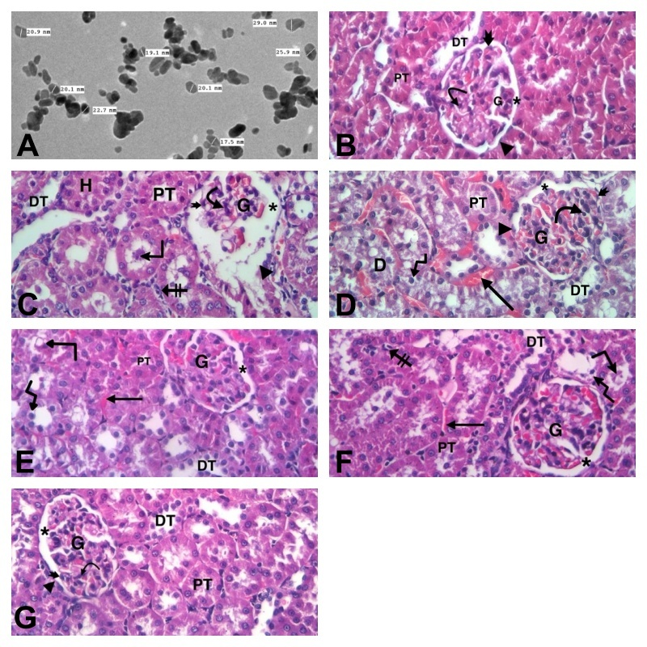
Fig (1) (A): The TEM image of zinc oxide nanoparticles showing that the prepared zinc oxide nanoparticles were in the nanoscale range with an average particle size of 20.04 ± 4.20 nm and spherical like shape. (Tem X15000). (B: G) photomicrographs of renal cortex sections stained by H&E (X400), (B): G1 (control group), the glomeruli (G) appear intact with its typical mesangial cells (curved arrow), podocytes (bifid arrow) and show Bowman’s capsule with its parietal epithelial cells (arrow head) and average size Bowman’s space (star). The proximal convoluted tubules (PT) are lined by cuboidal cells with rounded, basal nuclei and esinophilic cytoplasm and the distal convoluted tubules (DT) are lined by low cuboidal cells with central rounded nuclei and wide lumens and eosinophilic cytoplasm (C): G2 (MSG-induced toxicity group), the glomeruli (G) appear atrophied with vacuolation and notably widened Bowman’s space (star) with loss of its epithelial cells (arrow head). Mesangial cells (curved arrow) and podocytes (bifid arrow) appear with pyknotic nuclei The proximal tubules (PT) show intratubular hyaline deposition (H) and desquamation of lining epithelium in the center of the tubule (angled arrow). The distal tubules (DT) show flattened epithelium. There is inflammatory cellular infiltrate in the interstitial tissue between tubules (crossed arrow). (D) G2 (MSG-induced toxicity group) glomeruli show congestion of the intraglomerular capillaries (G). The renal tubules show degeneration (D) and vacuolation (zigzag arrow). Hemorrhage and congestion in interstitial tissue between the renal tubules are also noted (straight arrow). Notice: Bowman’s space (star), mesangial cells (curved arrow), podocytes (bifid arrow), parietal epithelial cells of Bowman’s capsule (arrow head), The proximal convoluted tubules (PT), The distal convoluted tubules (DT), (E): G3 (MSG + ZnO-NPs group) showing the glomeruli (G) appear nearly normal with a preserved Bowman’s space (star). The proximal tubules (PT) and distal tubules (DT) appear normal. while some tubules show desquamated cells in their lumens (angled arrow) and cytoplasmic vacuolation (zigzag arrow). Scanty hemorrhage is observed in the interstitial tissue between the tubules (straight arrow). (F): G4 (MSG + NSO group) showing that the glomeruli (G) exhibit congestion of the intraglomerular capillaries with slightly widened Bowman’s space (star). The proximal tubules (PT) and distal tubules (DT) appear nearly normal. However, other tubules show desquamated cells in center of their lumens (angled arrow) and vacuolated cytoplasm (zigzag arrow). Hemorrhage (straight arrow) & inflammatory cells (crossed arrow) are observed in the interstitial tissue between the tubules. (G): G5 (MSG + ZnO-NPs + NSO group) showing the glomeruli (G) with their normal appearance and nearly normal Bowman’s space (star), proximal tubules (PT) and distal tubules (DT) appear normal. Notice: mesangial cells (curved arrow), podocytes (bifid arrow), parietal epithelial cells of Bowman’s capsule (arrow head) (H&E x400).
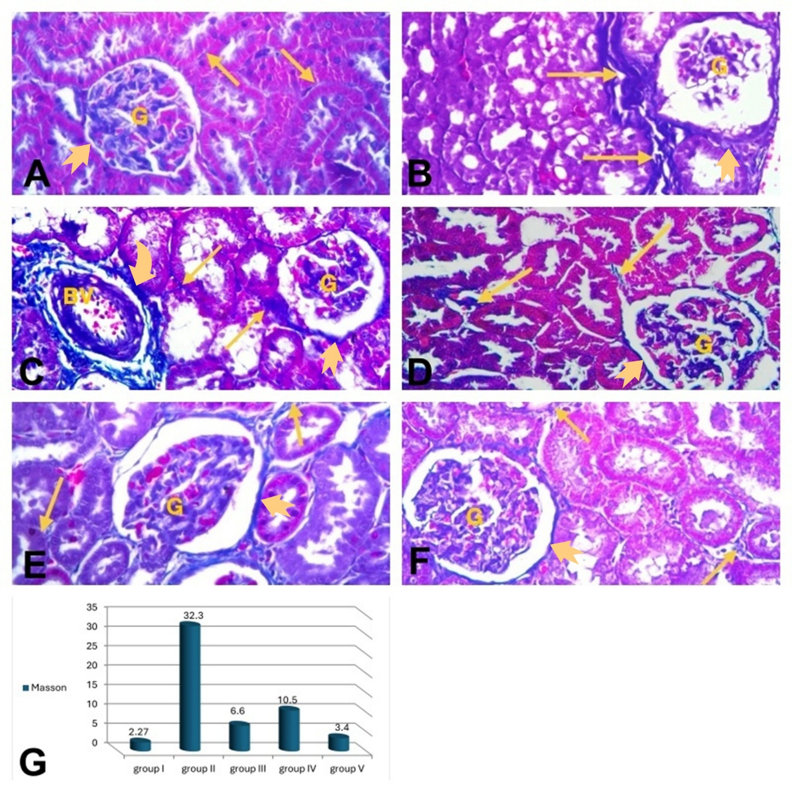
Fig (2) A photomicrograph of renal cortex sections stained with Masson's trichrome (X400), (A): G1 "control group " showing thin lamina of blue collagen fiber deposition around the renal tubules ( straight arrows) and around (G) glomeruli (bifid arrow) (B) : G2 "MSG-induced toxicity group " showing marked, blue-stained collagen fibers in interstitial spaces between the renal tubules (arrows) and around (G) glomeruli (bifid arrow) (C): G2 "MSG-induced toxicity group " showing marked, blue-stained collagen fibers around the renal tubules (straight arrows) and around (G) glomeruli (bifid arrow) and around the (BV) blood vessel (curved arrow) (D): G3 (MSG + ZnO-NPs group) showing mild, blue-stained collagen fibers in interstitial spaces between the renal tubules (arrows) and around (G) glomeruli (bifid arrow) (E): G4 (MSG + NSO group) showing moderate, blue-stained collagen fibers in the interstitial spaces between the renal tubules (arrows) and around (G) glomeruli (bifid arrow) (F): G5 (MSG + ZnO-NPs + NSO group) showing minimal, blue-stained collagen fibers in interstitial spaces between the renal tubules (arrows) and around (G) glomeruli (bifid arrow) (Masson Trichrome X400). (G): Histogram showing mean area percentage of collagen fiber deposition.

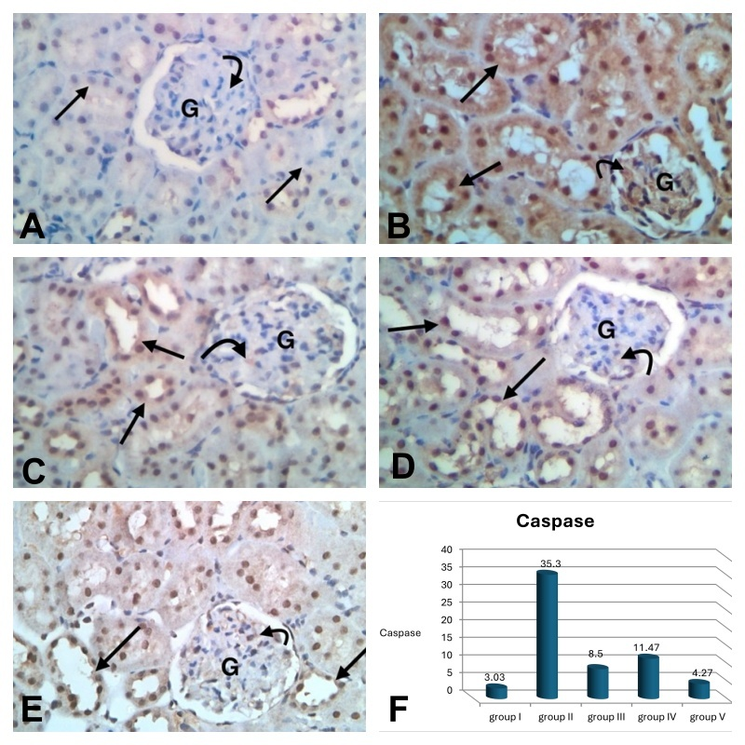

Fig (3) A photomicrograph of renal cortex sections showing caspase-3 immunostaining (X400), (A): G1 (control group) showing negative to very weak caspase-3 immunoreaction in the cytoplasm of mesangial cells (curved arrow) of the glomeruli (G) and renal tubules (arrows) (B): G2 (MSG-induced toxicity group) showing strong positive caspase-3 immunoreaction in the cytoplasm of renal cortical tubules (arrows) and in the cytoplasm of mesangial cells (curved arrow) of glomeruli (G) (C): G3 (MSG + ZnO-NPs group) showing mild caspase-3 immunoreaction in the cytoplasm of renal cortical tubules (arrows) and in the cytoplasm of mesangial cells (curved arrow) of glomeruli (G) (D): G4 (MSG + NSO group) showing moderate caspase-3 immunoreaction in the cytoplasm of the glomeruli (G) and renal tubules (arrows) (E): G5 (MSG + ZnO-NPs + NSO group) showing minimal caspase-3 immunoreaction in the cytoplasm of the renal tubules (arrows)and in the cytoplasm of mesangial cells (curved arrow) of glomeruli (G) (Caspase-3 X400). (F): Histogram showing mean area percentage of caspase-3 immunoexpression.

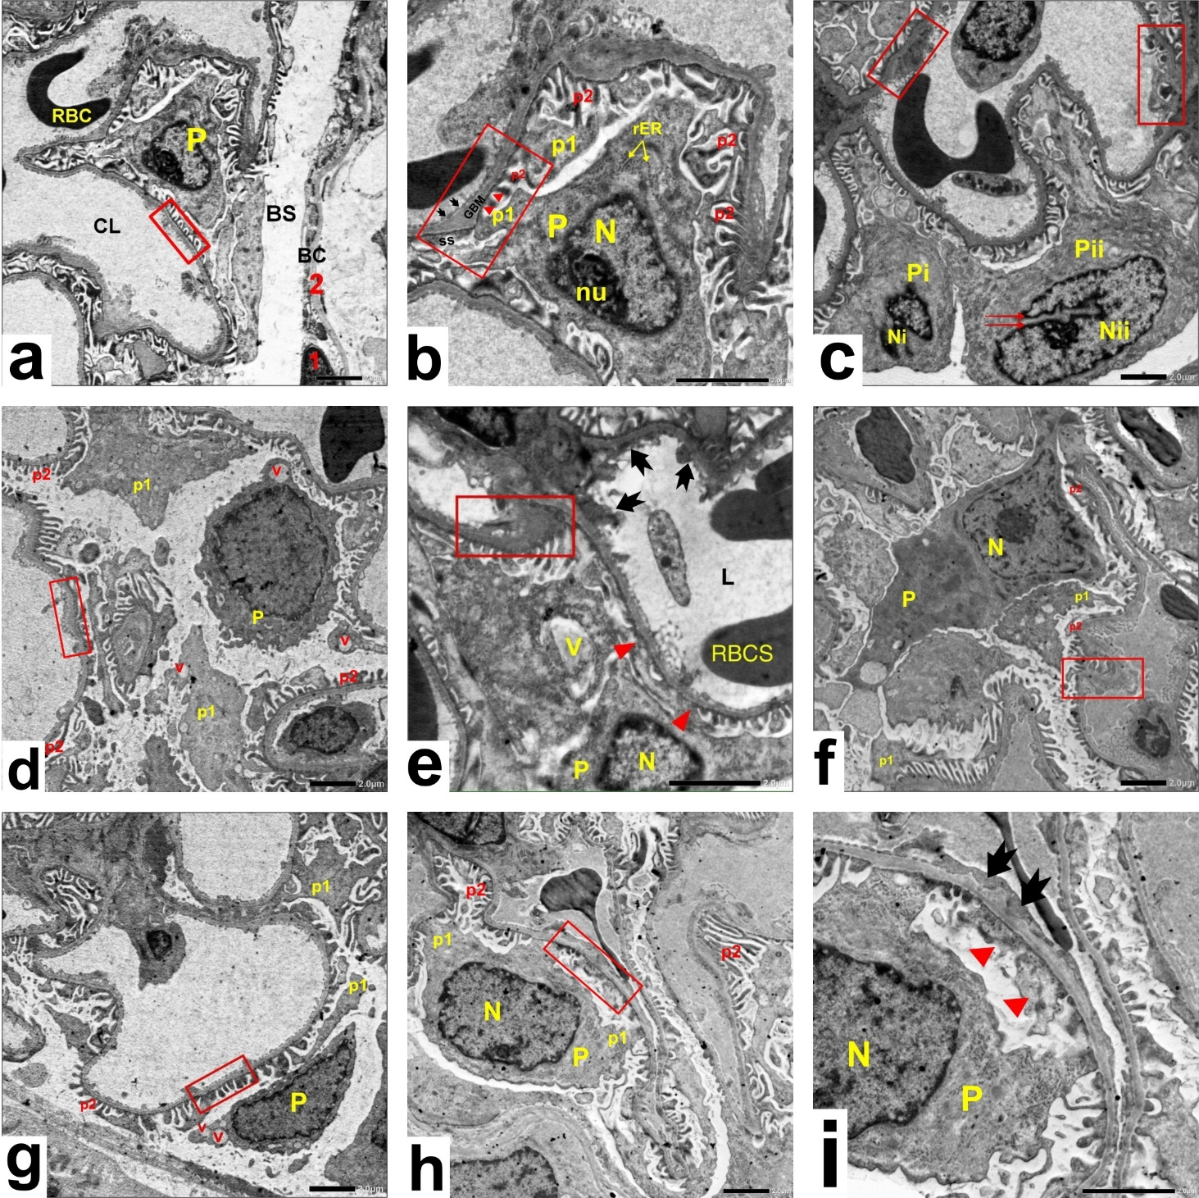
Fig (4): Electron micrograph of part of renal glomerulus in five groups :(a) group 1 Showing Podocyte (P) and its related capillary loop (CL) with (RBC). Part of Bowman’s capsule (BC) is seen at the periphery, consisting of squamous epithelial cell (1) and underlying basement membrane (2) and its Bowman’s space (BS). Notice; the filtration barrier (rectangle). (TEM X 7500). (b) group 1 (Higher magnification of the previous image) showing large podocyte (P) with its nucleus (N) showing nucleolus (nu). The cytoplasm shows rough endoplasmic reticulum (r ER) and gives primary (p1) and secondary processes (p2). The glomerular filtration barrier appears as tri-laminar structure (rectangle). The three layers are: the endothelial cytoplasm with fenestrations (bifid arrow), Glomerular basement membrane (GBM) and primary (p1) and secondary processes (p2) of podocyte with filtration slits (red arrow head) Notice; the sub-podocytic space (ss). (TEM X 15000). (c) group 2 showing small podocyte (Pi) with shrinked nucleus (Ni). another one (Pii) appears with its nucleus (Nii) indented (double arrows). The filtration barrier appears irregular, thick with obliterated slits (rectangles). (TEM X7500). (d) group 2 showing podocyte (P) with vacuolated cytoplasm (v), detached primary processes (p1) and secondary processes appear atrophied (p2). Notice; The filtration barrier (rectangle) (TEM X7500). (e) group 2 Showing podocyte (P) with small shrinked nucleus (N), vacuolated cytoplasm (v). The fenestrations of endothelial cells are obviously obliterated (bifid arrows). Secondary processes of podocytes showing areas of effacement with obliterated slits (red arrowheads) The filtration barrier (rectangle) appear with abnormal thickness. (TEM X 15000). (f) group 3 showing podocyte (P) with irregular nucleus (N). The primary processes (p1) are nearly normal, the secondary processes (p2) show effacement and part of the filtration barrier (rectangle) appears with abnormal thickness (TEM X 7500). (g) group 4 showing the cytoplasm of podocyte (P) is scanty and shows small vacuoles (v) with detached primary processes (p1) and nearly normal secondary processes (p2). The filtration barrier appears nearly normal (rectangle). (TEM X7500). (h) group 5 showing large podocyte (P) with regular nucleus (N), nearly normal 1ry processes (p1) and secondary processes (p2). The filtration barrier appears thickened (rectangle) (TEM X7500). (i) group 5 (Higher magnification of the previous image) showing part of filtration barrier with obliterated endothelial fenestrations (bifid arrows) and effacement of 2ry processes obliterating the filtration slits (red arrowheads). Notice; podocyte (P), nucleus (N) (TEM X 15000).

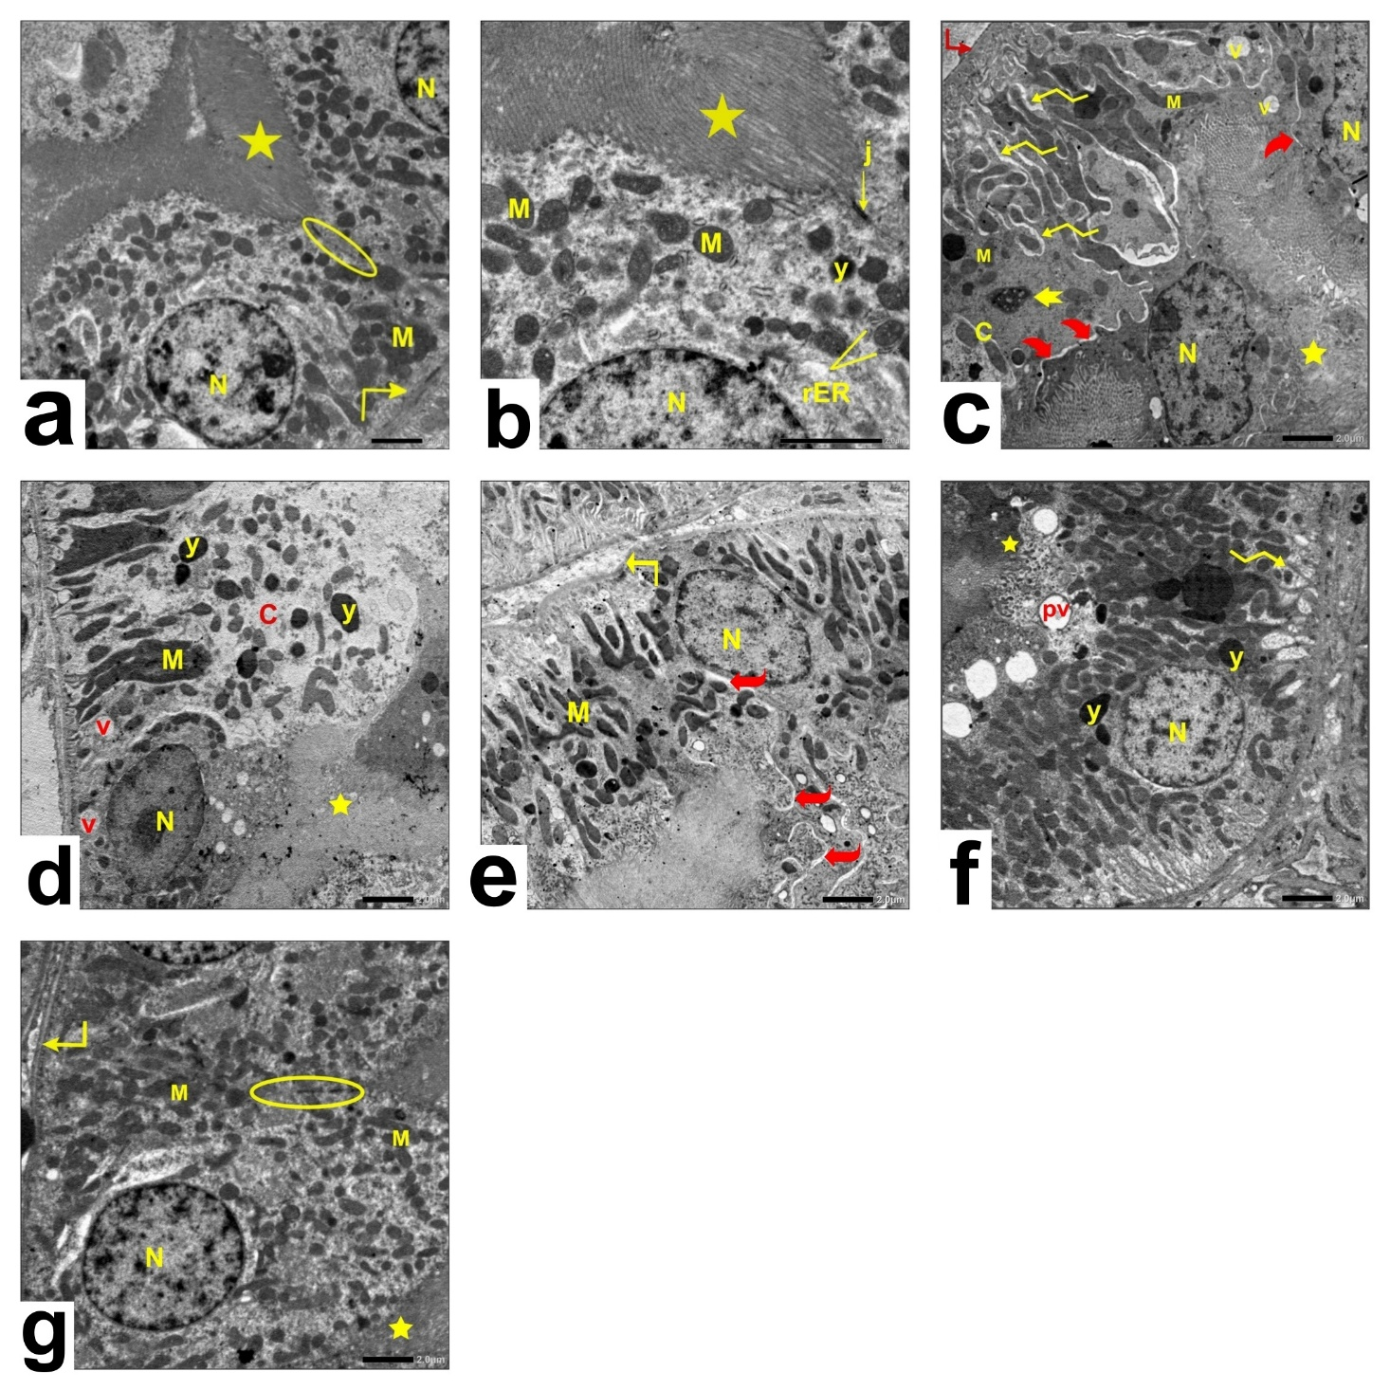

Fig (5): Electron micrograph of PCT lining epithelium in five groups (a): group 1 showing two cuboidal cells resting on thin regular basement membrane (angled arrow). The cells reveal rounded basal nucleus (N), apical microvilli (star), and multiple mitochondria (M) situated in the basal invaginating folds along the basal membrane. Notice; the lateral cell walls (oval). (TEM X 7500) (b) Magnification of the previous image showing the cellular organelles. Rounded nucleus (N), lysosomes (y), rough endoplasmic reticulum (rER), mitochondria (M) are obvious. The lateral cell wall with its junctional complexes (j) near the apical surface. The microvilli appear profuse, long and crowded (star). (TEM X 15000) (c) group 2 showing cells with irregular nuclei (N) displaced away from the basement membrane (angled arrow), irregular mitochondria (M), large electron dense material (secondary lysosomes) (bifid arrow) and cytoplasmic heterogenicity (C). Wide intercellular space (curved arrow), wide basal infoldings (zigzag arrow) and distorted apical microvilli (star). (TEM X 7500) (d) group 2 “another field” showing its cytoplasm (C) exhibit heterogeneity with regions appearing electron lucent, mitochondria appear irregular, variable-sized, elongated and fused (M), large lysosomes (y). cytoplasmic vacuoles (v) are apparent. Notice; nucleus (N), apical microvilli (star) (TEM X 7500) (e) group 3 showing irregular basal lamina (angled arrow), dilated intercellular spaces (curved arrows). normal nucleus (N) with normal variable sized mitochondria (M) (TEM X7500) (f) group 4 showing nucleus with partly irregular outlines (N) slightly distorted apical microvilli (star) lysosomes are present (y). slightly widened basal infoldings (zigzag arrow). Notice; pinocytotic vesicles (pv) (TEM X7500) (g) group 5 showing nearly normal cuboidal cell resting on thin regular basement membrane (angled arrow). The cell reveals rounded basal nucleus (N), apical microvilli (star), and multiple mitochondria (M) Notice; the lateral cell walls junctions (oval). (TEM X7500)
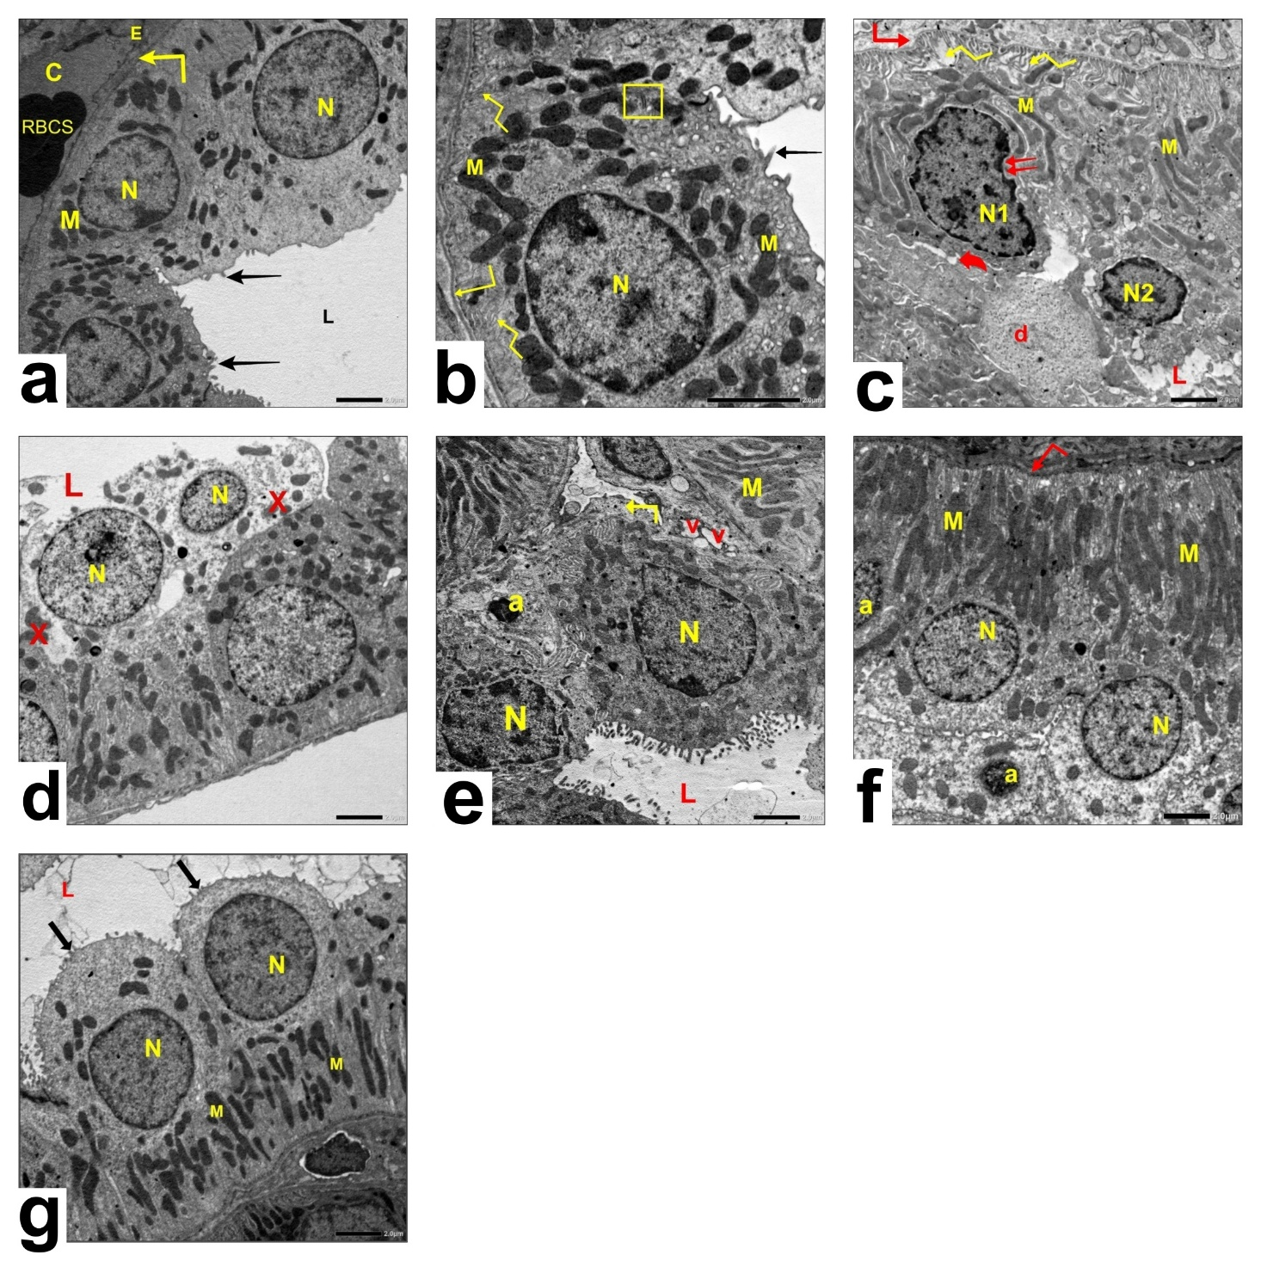
Fig (6): Electron micrograph of DCT lining epithelium in five groups (a) group 1 showing low cuboidal cells resting on basement membrane (angled arrow) surrounding the lumen (L). The cells appear with rounded nucleus (N), short few apical microvilli (arrows), mitochondria (M). The underlying connective tissue showing blood capillary (c) lined with endothelium (E) with red blood cells (RBCs) in its lumen. (TEM X 7500) (b) magnification of the previous image showing cuboidal cells resting on regular uniform basement membrane (angled arrow). The cells appear with rounded nucleus (N), a short few apical microvilli (arrow) and variable size mitochondria (M) and basal infoldings (zigzag arrow). Apparent tight junctions (square (. (TEM X 15000) (c) group 2 showing cells resting on irregular basal lamina (angled arrow), wide basal infoldings (zigzag arrow), irregular nucleus (N1) with indentation (double arrows) and another shrinked nucleus (N2) extruded to the lumen (L) which is filled with debris (d). The cytoplasm shows mitochondria (M) and wide intercellular spaces (curved arrow). (TEM X 7500) (d) group 2 “Another field” showing multiple cells (x) extruded to the lumen (L) (TEM X 7500) (e) group 3 showing cells resting on irregular basal lamina (angled arrow), irregular nuclei (N). The cytoplasm shows vacuolations (v) and irregular mitochondria (M). Small apoptotic cell (a) can be noticed. Notice; the lumen of the tubule (L) (TEM X7500) (f) group 4 showing some cells appear normal with normal nuclei (N) and mitochondria (M). other cells appear with apoptotic nucleus (a) and one is displaced away from the basement membrane (angled arrow). (TEM X7500) (g) group 5 showing nearly normal low cuboidal epithelium. The cells appear with rounded nucleus (N), short few apical microvilli (arrow) elongated mitochondria (M). Notice; lumen of the tubule(L) (TEM X7500)

Morphometric Study
Mean area percentage of collagen fiber deposition by Masson’s trichrome staining (Fig 2G- Table 1):
The mean area percentage of collagen fibers deposition was 2.27 ± 0.5% in group 1: 32.3 ± 9.9% in group 2: 6.6 ± 1.2% in group 3 :10.5 ± 1.2% in group 4 and 3.4 ± 1.2% in group 5
Mean area percentage of caspase-3 immunoexpression (Fig 3F-Table 1):
The mean area percentage of caspase-3 immunopositive cells was 3.03 ± 0.8% in group 1: 35.3 ± 8.6% in group 2: 8.5 ± 0.8% in group 3: 11.47 ± 0.7% in group 4and 4.27 ± 0.5% in group 5
Table (1) show mean area percentage of collagen fiber deposition & Mean area percentage of caspase-3 immunoexpression
 | Control Group | Group II | Group III | Group IV | Group V
Masson area % | 2.27 ± 0.5 | 32.3 ± 9.9  a, c, d & e | 6.6 ± 1.2  b | 10.5 ± 1.2  b | 3.4 ± 1.2  b
Caspase area % | 3.03 ± 0.8 | 35.3 ± 8.6  a, c, d & e | 8.5 ± 0.8  b | 11.47 ± 0.7  b | 4.27 ± 0.5  b

Data expressed as mean ±SD, *: significance ≤ 0.05 (Tukey's & Bonferroni test)
a: Significance vs Control, b: Significance vs group II, c: Significance vs group III, d: Significance vs group IV, e: Significance vs group V

